The 14th TSAE International Conference
12-14 May 2021
Available online at www.tsae.asia
Title, use font Times New Roman 12 pt, bold, Thai distributed, capitalize the initial character of each word except prepositions
For double blind review, please leave the author names and addresses and the corresponding author e-mail blank.
This information must be added later when you prepare the photo-ready version.
Author name¹*, Author name¹, Author name² (Use font Times New Roman 11 pt, bold, Distributed)
¹Affiliation, address (Use font Times New Roman 9 pt, normal, Thai Distributed)
²Affiliation, address
*Corresponding author: Tel: +66-8-xxxx-xxxx, Fax: +66-xx-xxx-xxx, E-mail: xxxxxx@xxxxx
Abstract
Arrange abstract in one column. Set the first line indentation to 1.0 cm. Use font TH SarabunPSK 14 pt with single line spacing and Thai distributed. The abstract should be concise but adequately describe the objective(s) of the study, methodology or approach used, results and important interpretation or findings, and reasonable conclusions. The length of the abstract should be no longer than 250 words.
Keywords: Word1, Word2, Word3

Introduction
The main body of text is arranged in two columns of width 8.25 cm each with a clearance between columns of 0.5 cm.
The main section should be numbered, for example, "1 Introduction", then "1.1 Sub-section1", using bold letters and left alignment. Start a new paragraph by leaving an indent of 0.5 cm. Type all of the main text using font TH SarabunPSK 14 pt with single line spacing and align both sides of the column.
The introduction should provide sufficient background and state clearly the importance of the work being reported as well as its focused objective(s).

Materials and Methods

Sub-section
Provide sufficient details of methodology and approach to allow the work to be reproduced. Established, published, or standard methods should be indicated by reference; only modification by authors should be described. Mention about commercial name of instrument to supply scientific details may be possible but sparingly and must not imply approval or endorsement of particular producer of the equipment.
Use the International Systems (SI) units, for example. Use the negative power to indicat reciprocal units, for example, use "m s⁻¹" instead of "m/s".
Equations should be typed with Equation Editor of the wordprocessing software. Place equation in a separate line with 0.5 cm indent and give sequential number. All variables in the equation should be defined.
(1)

Results and Discussion
Report of results should be clear, concise, and systematic. Table and graphical interpretation may be helpful in presenting the data, and that information should not be repeated in the description. Graphical illustrations should have at least 300 dpi.
Table 1 Put table caption above the table, Thai distributed.
Category | Parameter (unit)
 | Result 1 | Result 2 | Result 3
Data 1
Data 2
Data 3
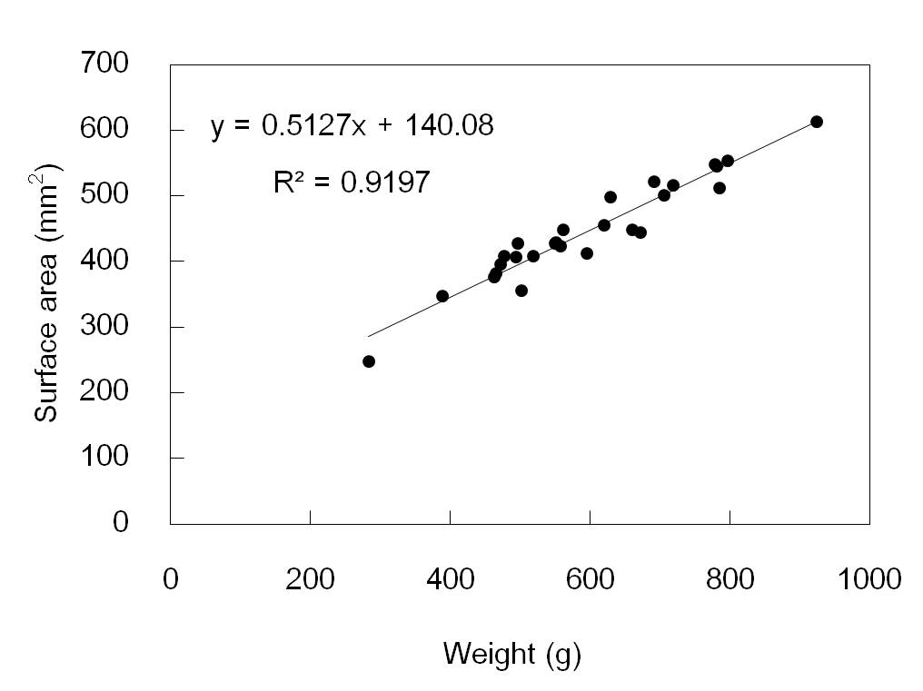
Figure 1 Put figure caption under the illustration, Thai distributed.

Table 2 If required, large tables or figures can be arranged in the single-column format.
Test | Parameterª (unit) | Parameter (unit) | Parameter (unit)
 |  |  | Result 1 | Result 1 | Result 1
1
2
3
ªUse superscripted letters to denote extra information.

Conclusions
Summarize major findings, opinion and resolution of the author which can be drawn from the work.

Acknowledgements
List those who provided assistance during the research (e.g., funding source, language assistant, proofreader).

References
References should be cited in the text by referring to the author's family name (without initials) and year of publication (e.g., "Mettam (1994) has shown that ..." or "These results were in the agreement with the results from an earlier study (Kramer, 1994)”). References with three or more authors should be cited with the first author followed by "et al." (e.g., Perez-Mendoza et al. (1999)). All journal titles should be given in full. Citations to sources that are not broadly accessible such as internal reports, unpublished data, or personal communications, should be avoided. However, they may be mentioned in the text.
References should be given in the following forms:
- Journal article
Perez-Mendoza, J., Hagstrum, D.W., Dover, B.A., Hopkins, T.L., Baker, J.E. 1999. Flight response, body weight, and lipid content of Rhyzopertha dominica (F.) (Coleoptera: Bostrichidae) as influenced by strain, season and phenotype. Journal of Stored Products Research 38, 183–195.

- Edited book
Mettam, G.R., Adams, L.B. 1994. How to prepare an electronic version of your article. In: Jones, B.S., Smith, R.Z. (Eds.), Introduction to the Electronic Age (pp. 281–304). New York: E-Publishing Inc.

- Book
Strunk, W., Jr., White, E.B. 1979. The Elements of Style. (3rd ed.). Brooklyn, New York: Macmillan.

- Conference proceedings
Winks, R.G., Hyne, E.A. 1994. Measurement of resistance to grain fumigants with particular reference to phosphine. In: Highley, E., Wright, E.J., Banks, H.J., Champ, B.R. (Eds). Proceedings of the Sixth International Working Conference on Stored-product Protection, 244–249. Oxford, UK: CAB International. 17–23 April 1994, Canberra, Australia.

- Thesis
Chayaprasert, W. 2007. Development of CFD models and an automatic monitoring and decision support system for precision structural fumigation. PhD dissertation. West Lafayette, Indiana: Department of Agricultural and Biological Engineering, Purdue University.

- Website

United Nations Environment Programme. 2000. The Montreal protocol on substances that deplete the ozone layer. Available at: http://ozone.unep.org/ pdfs/Montreal-Protocol2000.pdf. Accessed on 7 August 2008.

