Optimal mechanical harvester route planning for sugarcane field operations using particle swarm optimization
Woraya Neungmatcha and Kanchana Sethanan*
Research Unit on System Modeling for Industry, Department of Industrial Engineering, Faculty of Engineering, Khon Kaen University, Khon Kaen, 40002, Thailand.
*Corresponding author. Tel.: +00-0000-0000; Email address:

Abstract
This is an instruction for manuscript preparation for publication in KKU-IENC 2021. The abstract should contain a single paragraph describing objective, methodology and a summary of important results. Its length should not exceed 300 words.
Keywords: 4-6 keywords, separated by commas, the first letter of each keyword must be capitalized.

1. Introduction
Start the first paragraph and subsequent paragraphs with indentation. Use tab stops or other commands for indents but do not use the space bar. Primary headings should begin at the left margin in boldface.
This article demonstrates an example for you to prepare your article for submission to KKU-IENC 2021. Please strictly follow the guideline and only a .doc or .docx file is accepted in the manuscript submission. The minimum length of manuscript is 4 pages; and the maximum length is 15 pages.

2. Materials and methods
2.1 Paper size and margins
Manuscript should be created using MS Word. Please use A4 paper size (21x 29.7 cm), one-column format. All margins must be 2.54 cm and manuscript should have page numbers and line numbering, and use line spacing 1.5. Figure and tables should be placed as close as possible to where they are mentioned in the text.
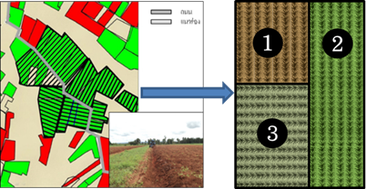
Figure 1 Direction of sugarcane planting groves

2.1.1 Structure of article
The article content will, in general, consist of the following headings: Introduction, Materials and Methodology, Results and Discussion, Conclusion, Acknowledgements, and References.
2.1.2 Figure and tables
Line drawings should be of high resolution and high contrast. For color or greyscale photographs (halftones), use a minimum of 300 dpi (.TIFF or .JPG).
Do not upload Excel files or images for tables. Use the table function of Microsoft Word.
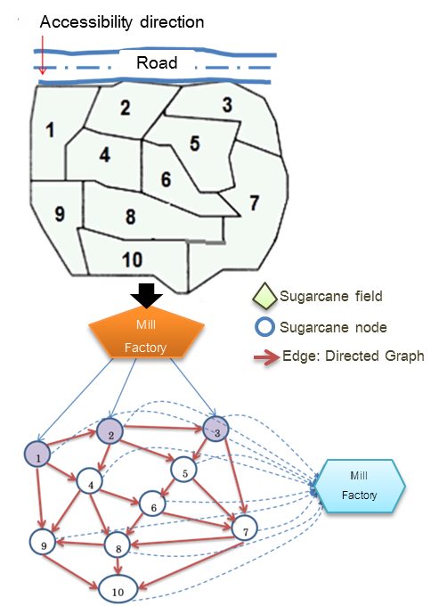
Figure 2 Directed graph of harvester
3. Results
The research results should be presented clearly and right to the point with accompanying figures and tables. These figures and tables should be referred to in the content. Explanation must not repeat what is already given in the content.

Table1 Design of test problems
Problem | n | Sp |  | L
1 | 10 | 2 | 200 | 500
2 | 15 | 2 | 150 | 1000
3 | 20 | 2 | 150 | 1000
4 | 30 | 2 | 150 | 1500
5 | 50 | 2 | 100 | 1500

4. Discussion
Research discussion is aimed at persuading readers by comparing with other research studies and proposing possible solutions or useful suggestions for solving certain research outcomes, etc. Research results and discussion can be written in one section.

5. Conclusions
The conclusion of points and important research elements should not be too long. Your article should be reviewed by all co-writers before submission

6. Acknowledgements
Acknowledgements is for the purpose of showing gratitude to research supporters. It should not be long. Your article should be reviewed by all co-writers before submission.

7. References
The References part should follow the Vancouver style, and only in English. Please ensure that every reference cited in the text is also present in the reference list. Use an Arabic number in parenthesis after the referred statement. For example, [1] or [2-4, 8, 10] refers to Author 1 or 2, 3, 4, 8, 10 ordering from 1, 2, 3,...to the last number which appear in the reference list.
7.1 Example of references
[1] Mostofinejad D, Khozaei K. Effect of GM patterns on ductility and debonding control of
FRP sheets in RC strengthened beams. Construct Build Mater 2015;93:110–120.
[2] Murray PR, Rosenthal KS, Kobayashi GS, Pfaller MA. Medical microbiology. 4th ed. St. Louis: Mosby; 2002.
[3] Meltzer PS, Kallioniemi A, Trent JM. Chromosome alterations in human solid tumors. In: Vogelstein B, Kinzler KW, editors. The genetic basis of human cancer. New York: McGraw-Hill; 2002. p. 93-113.
[4] Harnden P, Joffe JK, Jones WG, editors. Germ cell tumours V. Proceedings of the 5th Germ Cell Tumour Conference; 2001 Sep 13-15; Leeds, UK. New York: Springer; 2002.
[5] Christensen S, Oppacher F. An analysis of Koza's computational effort statistic for genetic programming. In: Foster JA, Lutton E, Miller J, Ryan C, Tettamanzi AG, editors. Genetic programming. EuroGP 2002: Proceedings of the 5th European Conference on Genetic Programming; 2002 Apr 3-5; Kinsdale, Ireland. Berlin: Springer; 2002. p. 182-91.
[6] Borkowski MM. Infant sleep and feeding: a telephone survey of Hispanic Americans [dissertation]. Mount Pleasant (MI): Central Michigan University; 2002.
[7] Cancer-Pain.org [Internet]. New York: Association of Cancer Online Resources, Inc.; c2000-01 [updated 2002 May 16; cited 2002 Jul 9]. Available from: http://www.cancer-pain.org/.
[8] Wikipedia. Generation Y [Internet]. 2011 [cited 2011 Jul 5]. Available from: http://en.wikipedia.org/wiki/Generation_Y
8. Reviewer
The authors are invited to suggest 2-3 potential reviewers for their papers. Please provide their full names, institutions, and email addresses. It should however be noted that the technical committee team may or may not select those suggested reviewers.

